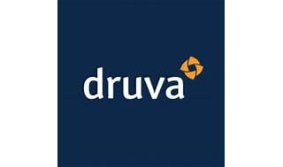

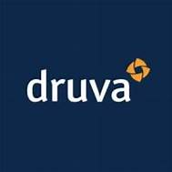

Explore

**Druva** is an American privately-held software company based in Santa Clara, California, providing **SaaS-based data protection and management products** for enterprises and government agencies. [Their innovative approach to backup and recovery ensures data security and utilization across various data risks1](https://en.wikipedia.org/wiki/Druva).

Here are **five free learning resources** where you can explore more about Druva:

1. [**Data Resiliency For Dummies®**](https://www.druva.com/resources/ebooks): Overcome data risks in a few key steps.
2. [**Druva Resource Center**](https://www.druva.com/resources): Access documents, customer stories, videos, and more.
3. [**Druva Academy**](https://academy.druva.com/): World-class training program to configure, deploy, and maintain Druva products.
4. [**Modern Data Protection vs. Legacy**](https://www.druva.com/resources): Understand the advantages of Druva’s fully managed, 100% SaaS approach.
5. [**Critical Steps for Scalable, On-Time Recovery From Ransomware**](https://www.druva.com/resources): Learn how to recover faster and prevent data loss.

Feel free to explore these resources to enhance your understanding of Druva’s offerings! 🚀🔒